 | Behavior Change | Date | Description (1-2 Sentences) |  | Picture Evidence
 | LED bulb replacements | 2019 | All incandescent bulbs around the building have been replaced with LED bulbs. The BOS has estimated a total of 40,000 bulbs since the switch has been made. |  | 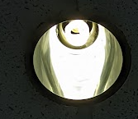
 | Installation of movement sensing light switches | 2017 | These turn off lights in a classroom if there is no movement in 10 minutes. This helps when lights are left on to save electricity. |  | 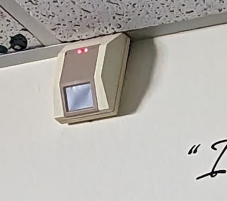
 | Electronic newsletter | 2020 to present | Towson high releases a biweekly electronic newsletter to all staff, students, and parents instead of a paper one. |  | 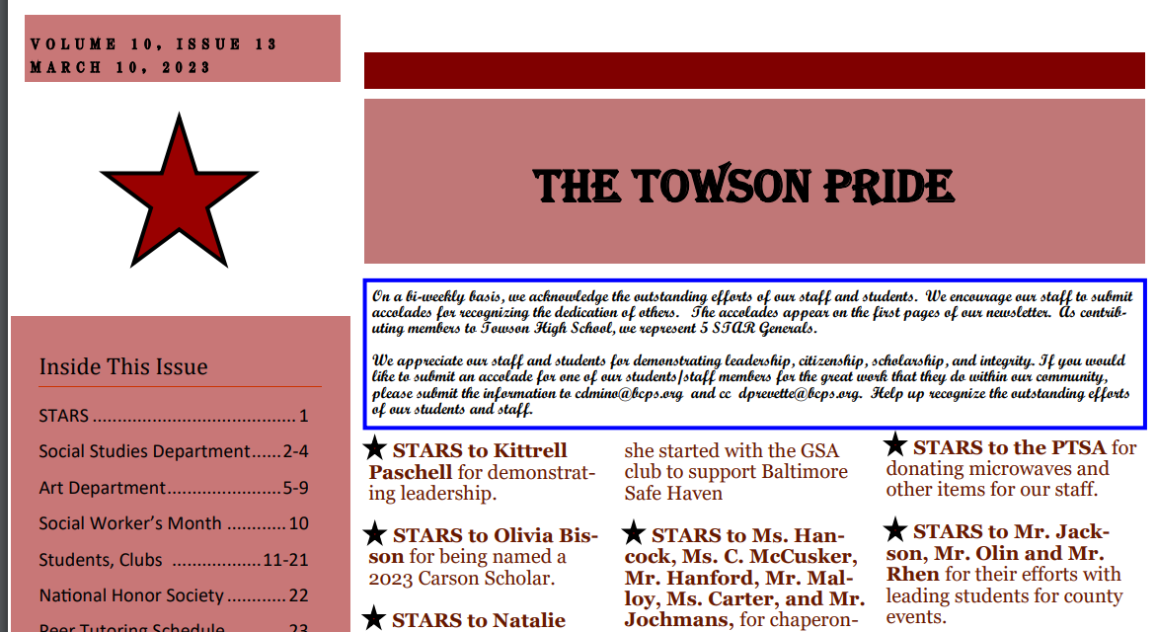
 | 4 pages on 1 paper | 2018- present | Teachers often print assignments with 4 pages on 1 sheet to conserve paper. |  | 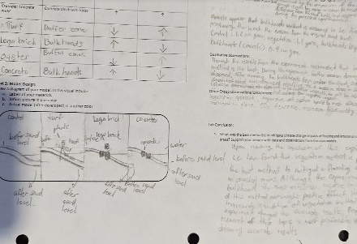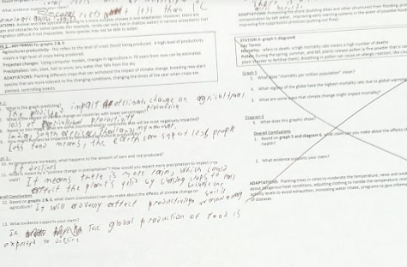
 | 2 pages on 1 paper | 2016- present | Teachers always print on fronts and backs to conserve paper. |  | 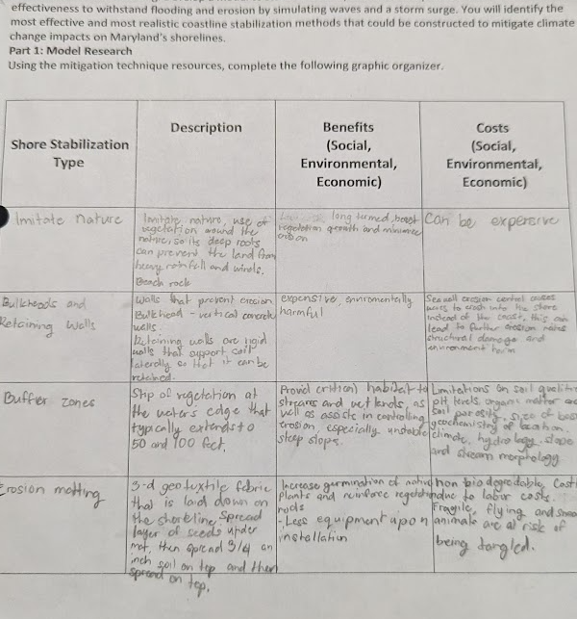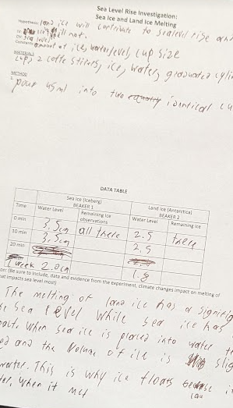
 | E-packets | 2018-present | Teachers often post long assignments online to conserve paper instead of making packets. |  | 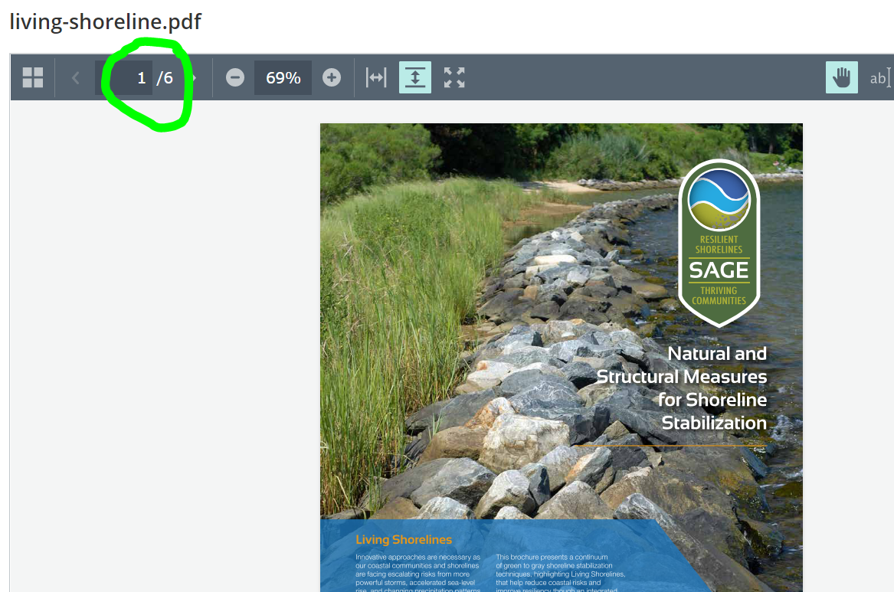
 | Teaching with daylight only | Whenever applicable | Some teachers in the school use natural light as much as possible |  | 